Laboratory Assignment
On
Design Principles of Operating System
(CSE 3249)

Submitted by

Name : Dinanath Dash
Reg. No. : 2241004161
Semester : 5th
Branch : CSE
Section : 2241026
Session : 2024-2025
Admission Batch : 2022



DEPARTMENT OF COMPUTER SCIENCE & ENGINEERING
FACULTY OF ENGINEERING & TECHNOLOGY (ITER)
SIKSHA ‘O’ ANUSANDHAN DEEMED TO BE UNIVERSITY
BHUBANESWAR, ODISHA – 751030
- Write the commands to create the following directory hierarchy: -> DOS_Regdno ->DOSass1->dir1
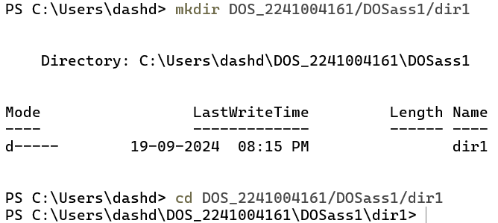

- Write the commands to create another directory with name dir2 in directory DOSass1 and make dir2 as the current working directory.
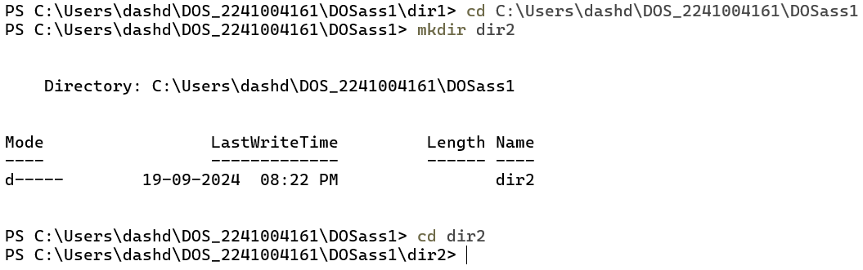

- Write the command to delete the directory dir2 , when DOS_Regdno will be the current working directory.

- Write the command to create a file named as file1 using cat command inside dir1. Write your name, regdno, branch, semester and section in file1. Then display the content of the file.

